Akwete Weave

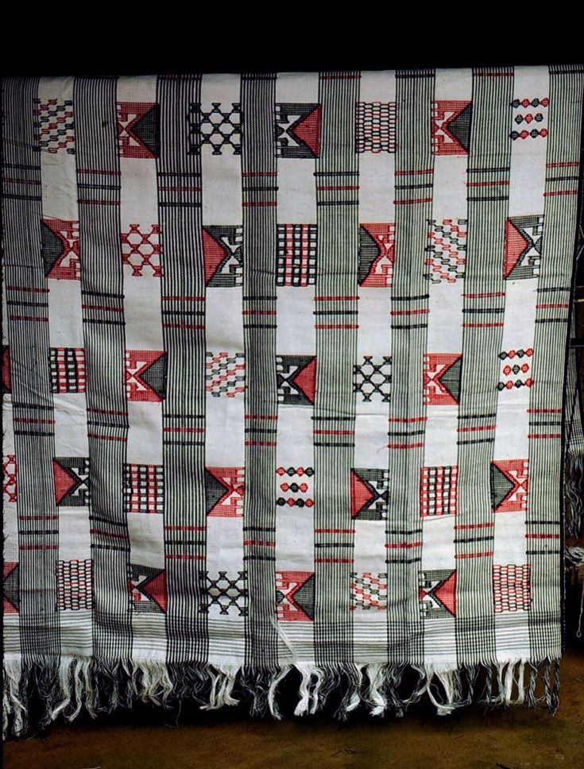

Peter Schmidt

pixel press

Swarthmore, Pennsylvania

Poems

Bloomdido for the Improvisors
Neo Colossus
Security Directive
Produce
Speck
Elegy Natchez Country
Octavius V. Catto
Starling Shout-Out
Shadows on the Highway

cover image
Akwete cloth. Igbo artist, Nigeria. Photo by Lisa Aronson
https://africa.uima.uiowa.edu/media/photos/show/920
Bloomdido for the Improvisors

Honoring the first century or so of jazz
everyone’s different ways of knowing the tradition:
—for Albert Murray and Angela Davis;
and for Sonia Sanchez, neighbor and instigator

My parents playing Louis Armstrong 78s,
“West End” and “Tin Roof” blues,
Introducing the blue horizons of Sidney Bechet,
Jelly Roll Morgan’s Red Hot Peppers,
Aristocracy à la Edward Ellington, or Prez,
Mary Lou Williams’ zodiacal soul on soul,
Count Basie’s jump-up from the get-go,
Charlie Christian on guitar, the smo-o-o-oth one,
And one of the other blues God blessed Billie Holiday,
“Tell me more and more and then some,
...The waiting’s been so long,
It’s hard to be believin’ ”—

Better than this
There’s only silence,
And better than silence
Only Miles with a mute.

Bird’s clarion “Ko Ko” outsmokes even Duke’s,
Monk’s brilliant corners, crepescule in the face of fools,
Con alma the ebullient Mr. Gillespie,
Sinatra singing “What is this thing called love?”
Soaring sweet Brown and Roach, Inc.,
And Sonia Sanchez’s praise to the Max:
“You came warrior/clear your music/kissing our spines.”
In Havana and New York, para bailar
El montuno, Arsenio Rodríguez y su Orquestra,
Mario Bauzá, 944 Columbus Ave.,
Con Machito el corazón of the Palladium,
Billy Strayhorn, swee’ pea, fleurette américain,
Ah um! fight song aka Charles Mingus,
And cruising beyond the ages and Philadelphia’s
Germantown, Sun Ra and His Arkestra
“Through the darkness of the light years,
And the light years of the darkness”—

Better than this
There’s only silence,
And better than silence
Only Miles with an open horn.

Art Blakey’s pressroll: seedcrop for the next generation,
Ornette spilling the alphabet on beyond zebra,
Coltrane sound of the underground tranesonic,
Out to lunch and other aspects: Eric Dolphy,
Cecil Taylor, conquístador!
And Yusef Lateef, plum blossom,
Sassy Vaughn gone velvet, Newk questing on the bridge,
Nina Simone black gold beyond category,
Dorothy Ashby’s hip harp rascality,
Alice Coltrane astral meditations stirred in with
Cal Tjader’s and Willie Bobo’s soul sauce,
“Yo le canto a la luna” by Gato Barbieri,
“Azúcar! azúcar!” en Nuyorican plena
O Cachao putting the charge in la descarga—

Better than this
There’s only silence,
And better than silence
Only Miles, in a Spanish key.

Art Ensemble of Chicago, Southside ancients
To the future, Henry Threadgill’s bush rags
‘N’ pocket demons, “Peace in Essaouira, Morocco
(For Sonny Sharrock)” from Pharoah Sanders,
Rubén González, a Mandinga cosmos spanning
Eight full octaves, y La Voz de la Experiencia,
Celia Cruz, from Sonora Matancera
To La India forty-some years later: still time
For Cassandra Wilson’s smoky crescent alto,
Jon Jang & Vijay Iyer: Pan Asian directions,
Redress & rainbow, new names
Pronouncing themselves daily, though many
Not named here, many paid only with dues,
But still unstoppable after all this time
Ed Blackwell’s polypolyrhythm marches on,
His quizzical metaphysicals asking “what it be like?”

Better than this
There’s only silence,
Don Cherry’s “Voice of the Silence,”
And better than silence
Only electric Miles, Pangaea.

Kenneth Victor Young, Untitled (Abstract Composition), acrylic, 1972.
Swann Gallery, New York

The Neo Colossus
(aka Emma Lazarus’ Statue of Liberty Poem, Revised 2017- )

“Give me your privileged, not poor,
Your neoliberals yearning to invest,
Entrepreneurs stuffed with d’or galore:
For us, elite and Christian now are best,
I lift my lamp beside our gold-plate door!”

Security Directive

“See something? Say something!”
says the security directive —

Graffiti chockablock letters explode in 3-D off a wall
signed “Rat King :: So It Goes” —

Sparrows in a sun-warmed garden
minutely inspect every inch of wall
for seeds in crannies or nooks of brick
then fly in a burst to a chain-link fence
at ease on corners of the wire diamonds —

“Live Rare Nude Show” truck on cinderblocks
painted pasties and garters fading
as it rusts in a junkyard by the tracks —

Penn Relays track-and-field teams
rustling in their warm-up suits
do rollover stretches &
leg kicks and sprints.
They share the same workout space
but keep respectful distance from each other —

Bumblebee checking me out
legs dangling down
like miniature landing gear.
When he swoops close to the pavement
his wings ablur suddenly make
fallen cherry-blossom petals skitter —

Dusk comes on.
Phonelight cupped in many hands
makes the faces of their owners
glow like candlelight —

In South Korea as a ferry sinks
“Don’t move” the intercom says.
“If you move, it’s dangerous. Don’t move.”
Potential ID marks for the dead
(clothes, moles, scars, tattoos)
are handwritten on whiteboards
in numbered spreadsheet cells.
Crowds press forward.
Two teenagers, a boy and a girl,
later become famous on TV:
Their bodies were found floating
on a ceiling inside the boat
lifejackets carefully
knotted together —

Plastic bags balloon in the wind
caught on razor wire —

“Mr. Speaker, witch-hunts happen
because there’s a witch somewhere.
Everything
we do in this body
should be about messaging” —

In my city yesterday, in Grays Ferry,
3 people were shot dead.
After the bodies were taken away chalk outlines
on the street make them look as if they’re running.
Tiny yellow plastic triangles
dot the crime scene & number
each brass bullet casing
destined for evidence bags.
So careful we are, so forgetful
Charon lugs new bodies into his boat
then poles them languidly across Lethe
his face a blank, his touch strangely tender

At Woodlands Cemetery near
University City the stone statues
stand with straight spines & sport
their best nineteenth-century finery:
As I sway and click by on my train
a granite gentleman with
cane and wide-brimmed hat
his face in shadow
takes a long quizzical look toward
our unrecognizable future —

Produce

To water South Jersey beans, tomatoes, peppers, and whatnot
a large hose with a cannon-sized nozzle
is sometimes wheeled out between the rows and opened up.

At the base of the nozzle is a long metal arm
attached at its middle, with a weight
on one end and the other end spatulate and spoon-like.

As the water jets, this thing-a-ma-jig floats like a see-saw
until the spoon-y end swings from the side
and suddenly thwacks the water as it shoots from the hose.

The spoon-end is then thrown backwards until the weight
at the other end makes it swing slowly
towards the jet to crash into it again. What’s it there for?

To nudge the water’s angle steadily to one side?
For the hose spurts water out
at regular intervals, moving just a little to one side each time,

until it meets the limit set for its motion, when it quickly
swoops back to its starting position and
begins again. But there may be something at the hose’s base

preset to handle this, to wet solely the right segment of field.
Maybe the thwacker gizmo
is there just to change the way the water spreads and falls,

so the jets don’t uproot the crops. It strikes the spurts just
at their base, making the spray spritz.
But the spouts would soften anyway, never pummeling

the plants, for they lose motion swooping to the end of their flight
and fall gently in silvery sheets and veils.
Maybe instead it's there to spray plants near the rainmaker’s base,

while the nozzle douses those at the far end of the arch,
rain for one and rain all around,
neither too little nor too much, no hail or lightning,

no stalk-twisting gusts, just a shower on wheels,
though not for free,
a port-a-storm complete with a watch-a-ma-call-it mister,

a clanking cumulo-nimbus cloud towable by tractor.
The produce takes it all in.
Soon there will be containers stacked at the end of each long row,

long hours and sweat from nose and chin watering the sandy soil,
quick wrists and español
rising and falling, row on row, dolores para dólares,

while it all becomes someone else’s store-bought bounty
sprayed in front of mirrors
and bushel baskets as if it just spilled over.

Speck

An ant crawls up my leg to my knee, tickling me.
I flick him (?) off with my finger, sending the black
speck

tumbling through air into long-bladed grass
over a yard away. How can he survive such a blow?
(Ants

mostly do.) Is flying just another event for him, nothing a
compound eye can’t handle? How does he figure out where he
is

when he lands, and what to do? I’ve disrupted his scent trail. The grass
must seem a jungle, so different from the patio desert we were in when
he

decided to ascend, threading through hair forests and over strange knobs
in quest of I have no idea what. Does he just adjust bravely to each new
world

and set off on his journey as if it’s still all of a piece?
I can’t know for certain, but as I sit here dreaming
I

somehow know he knows precisely where his ant-hole is.
His task remains fixed too. He searches anywhere he is.
Six

legs planted on whatever surface comes his way, he raises those delicate
ant mandibles, calipers for the infinite, and gets on with job
one.

Elegy Written in a Natchez Country Churchyard

—for Robert Hayden

Old cemeteries where the headstones
always face the church and the edifice
itself resolutely draws its axis

east/west: solstice sunlight enters eastern
windows to grace the altar and shadow
forth a judgment and the end of time.

Recent churches often face the road
instead, like the headstones that surround them.
This shift means something else has shifted too,

though what we don’t know and it seems so normal
no one notices. Along the Natchez
Trace one road erases all but traces

of another. There’s also a turnoff
for a burial mound. It faces west
and rises to a sunset overlook.

No telling how the bodies inside were
placed. The park plaques instead retell tales
of Indian atrocities—killing

family “retainers” (what a word) so
they were forced to serve in the next life. All
allegoric innuendo for why

they lost their right to live on Natchez land
while history makes them prehistorical
(or parenthetical). Was it a new

sun-god or a right-of-way that made them just
a line to be erased before rewriting?
(Yet those who follow are retraced themselves

to wait and watch the roadway as they go.)

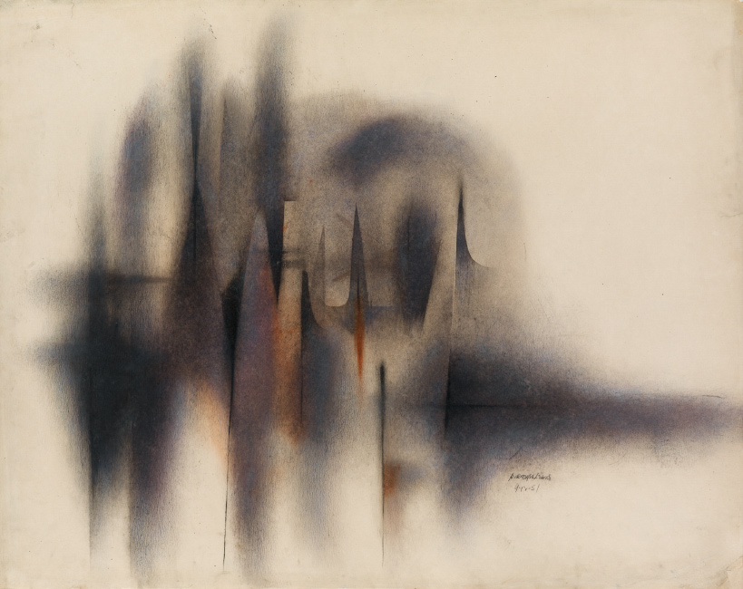

Norman Lewis, Untitled (Abstract Composition), oil and ink on paper, 1951.
Swann Gallery, New York

Octavius V. Catto
Philadelphia 1871, 2017

Does Branley Cadet’s statue
capture the moment when Catto
was shot pointblank in the back
at Ninth & South for
having the audacity to
talk back & push for jobs, voting rights,
and being a Pythians base ball
star on a diamond in the city

or the instant when, almost
like an angel wearing sturdy boots,
Catto spreads his arms, rises
on one toe, & ascends
welcoming us into the new
history of the would-be nation
he fought for and brought

(tried his damnedest to bring)

into being?

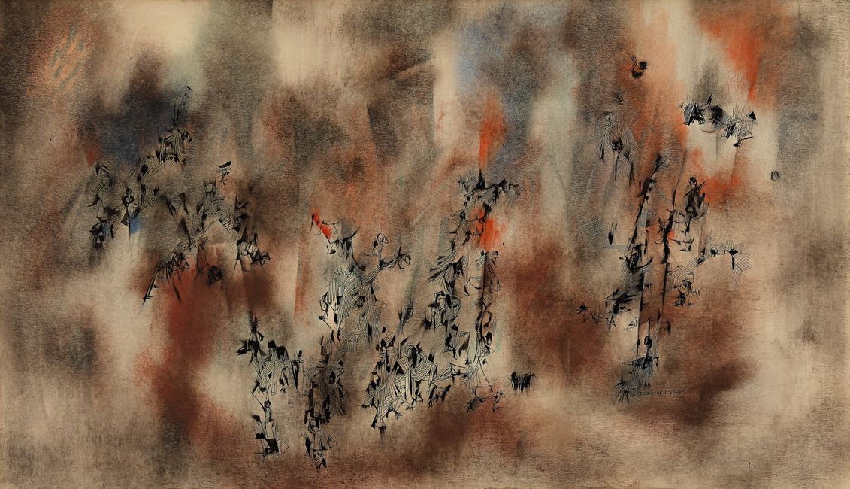

Norman Lewis, Untitled, oil and ink on paper, 1960.
Swann Gallery, New York

Starling Shout-Out

Several hundred common starlings were released in 1890 into New York’s Central Park by Eugene Schieffelin. He was president of the American Acclimatization Society, which tried to introduce every bird species mentioned in the works of William Shakespeare into North America. See Steve Mirsky, “Call of the Reviled,” Scientific American, 1 June 2008. https://www.scientificamerican.com/article/call-of-the-reviled/
“The common starling is a noisy bird.” —Wikipedia.

Drilling the mulch with its yellow
prod of a beak, gimme that, gotcha
punk with short-tailed swagger and swank
an iridescent sheen on basic black
unctuous oils spilling the spectrum
in the right light more, ever more, over
the whole continent from first clawhold
just another New York City migrant—
a murmuration as American as you are,
chump, & don’t you forget it,
anything can make a nest, even trash, omni-
vore and scavenger, take that! $@#%~!?$
POW! plus a knack for bone-grinding sounds,
such pops & scrunches from its
masticating noise-maw you’d think
you’d got a glimpse into the raw where
speech come from, as buzz-sounds
break it down to pips and quawks
the tags & undulineaments of
all that’s new

Shadows on the Highway

—This story is set approximately during the years 2010-2017.
Since then things have gotten worse.

A teenage girl from Benin City, Nigeria—
Adaora, “Daughter of Us All”—heads north
to look for work. Her family can’t support her,
they need her wages but there are no jobs.
First challenge is to get to Agadez in Niger
without getting robbed of the USD$650
she’ll need for smugglers (“tchagga”) to take her
across the Sahara into Libya, where
rumor has it there is work.
But Adaora gets robbed.
By police. At a checkpoint outside Agadez.
They guess her money’s secret hiding spots
then make a great show of filling out a receipt.
But when they hand it to her it’s blank
and they think the expression on her face
is hilarious. Now Adaora
must get new money any way she can,
but there are not any ways to do that other than
to sell herself. All the women shrug and tell her so,
it’s the way of the world. Adaora learns quickly that
government officials promise to pay but then usually
don’t: get the money ahead of time.
Blowjob by blowjob (and other acts) she gradually
grows a pile of money to hide in dirty laundry
when no one is looking, praying she’ll not be robbed again.

Adaora’s ride north is in the back of the first of many
Toyota pickups, little padding, a dozen others, a tarpaulin
to keep out only some of the blowing dust and sand, 1600K
and what feels like 16000K of ruts in a trans-Sahara road
following the same routes of the ancient slave
and salt trade. Soon after leaving Agadez the road
passes near a new U.S. military base, its North African
center for drone counterterrorism—but no passenger in the truck
is aware it’s there, and what Adaora is experiencing
doesn’t count as terrorism. At each transfer point
Adaora is in danger of being raped and robbed
again. But she arrives, bruised yet intact.
Adaora works for a year in Tripoli, Libya,
in houses and offices and refusing sex work.
The country’s in chaos but there is always
cleaning work. A woman she meets promises to help
her cross the Mediterranean. Adaora is uneasy,
for the woman won’t keep eye contact,
looking at her once and then away
as if she’s seen enough. Madame, for that is
what she wants to be called, wears
blue eye shadow, its color sprinkled with gold.
Who else can Adaora trust to find the men
with boats? But once inside Madame’s van
Adaora is kidnapped and taken to a Libyan man
who proudly announces he’s a buyer for a sex
syndicate of Italians and Nigerians in Naples.
They specialize in putting West African girls
on the streets of Italy and anywhere else in Europe.
That will be the price of passage, plus his fee.
The man wears sunglasses indoors and
too much cologne. Adaora screams “No, never!”
so loudly he turns down the sale in disgust.
Madame then whips out her cell and calls
Adaora’s home number (she’s forced it out
of her) and demands a ransom: USD$1200,
or 1200 more than her family can spare.

In Benin City
Adaora’s mother has a stand in the marketplace,
goes to her sister stall-owners
pleading for help. They dip into their
savings and raise the money. They all
know families who have sold a daughter
to pay back loan-shark loans
but this is almost as bad. Ransomed,
Adaora works another year in Tripoli, earning
passage on a leaky dinghy heading
north to Sicily. She sits packed tightly against
the others, listening to the outboard engine,
praying it won’t cough and stop, wrapping her brightly
colored ipele shawl more tightly round her shoulders.
Inside is sewn her mother’s phone number
so that someone kind might call her
if Adaora’s body washes up on shore.

Unlike many, maybe most, Adaora makes it,
cold water rising to her ankles
by the end of the voyage. She gets help from a refugee
center, papers and foster homes hosted by both
Italian and African families, and eventually
a job cleaning apartments and offices, low wages
but better than sex-slave riches. Over a year or so
she works her way up the peninsula,
always in a new city’s underground,
saving a little to send home, aware she’s now
the exception, not the norm. She hears of girls and
women from Africa and Eastern Europe imprisoned
in buildings, drugs sold on one floor, women
on another, and guards with Uzis all around.
She hears of women who have juju thrown from a distance
and laid on them—not juju music but a contract-curse
made of their own hair and blood, activated
if they leave the trade. Adaora also hears of women
who have a chance to leave but refuse, their families need
large sums sent each month, whole neighborhoods
in Nigeria with houses brightly renovated
from slave wages. There are whispers too, told half in disgust
and half in awe, about women who fought to rise in the system
and are now a “Maman” or “Madame” empowered to work
with gangs such as Black Axe, buying girls
like they were once, girls who arrive in Italy
tens of thousands of Euros in debt, a lifetime
to pay off even if they live a long time,
which many do not. And whispers of what’s
happening now to migrants out of Libya—
men and women “rescued” in mid-voyage by Libyan militias,
robbed and returned to detention camps and sold
to the highest bidder. Bullwhips slash through the air
from Libyan Coast Guard boats, falling on bare backs.
“We have to punish them to calm them down,”
says Ramzi Ali, shrugging, as he boasts of the phone
video he’s made to share. “We need to keep control.
They can take our life.”

For those like Adaora,
getting a residency permit is another deadly crossing
turned dead-end road for most. Forged documents
from a “facilitator” take years of savings,
though a few bribes from traffickers make it easy
to obtain certificates stating a girl is 18 or older,
her sex work legal, both police and pimps
happy to collaborate. It’s not just sex workers and migrants
who are on the streets and in the buildings
yet always underground, dark and officially in the dark.
These days the trade in migrants pays even better
than drugs or oil. Millions of workers permanently a part
of a low-wage economy that takes takes takes
from migrant labor then scapegoats those same workers
for stealing jobs, even jobs “natives” refuse to do,
jobs they say are too hard and too “demeaning.”
Meaning what, exactly? “We are ghosts,”
says a friend of Adaora’s, “shadows on the highway,”
yet shadows who eat and work and eat and work
and, sleeping, dream
of a different welcome in a different world.

Why do some think of themselves
as free and others as merely prey
—or shadows? Shadows cast but shadows
we don’t want or need to see?
Especially when “North” and “South”
all subsist in the long shadow of colonialism,
were constituted by colonialism? What we have now
seems like old trouble in new guises.
Sankofa, the Ghanaians say: “go back
and get it,” to go forward you must go back,
not to a fake past but to a painful one.
Dear reader, Agbonserema,
Welcome to the World you and I
and our ancestors have made. Like Adaora,
Daughter of Us All, you too must migrate,
place yourself in danger, work to be free. Ase!

Notes

Ase (pronounced asháy) is “the power to make things happen,” or an exclamation equivalent to “so let it be!” Yoruba.

Agbonserema and Adaora are two of many popular baby names used in Nigeria, with Agbonserema for a boy and Adaora for a girl. Their meanings in English are given above. These two names have links to Benin and the Igbo, respectively, but may be used throughout Nigeria.

Juju in Yoruba means “throwing” or “something being thrown.” It applies both to curses or spells and, in very different contexts, to the powers of music, including both Afro-Beat and Juju styles popular in the 1970s through the early 2000s, particularly with musician-composers such as Fela Kuti and King Sunny Adé. https://en.wikipedia.org/wiki/Jùjú_music

Some details for this narrative poem are indebted to these and other articles online and in print:

Anonymous. “Migrants Risk All to Cross Desert.” Irin News Service. Agadez, 9 October 2008.
http://www.irinnews.org/report/80835/west-africa-migrants-risk-all-cross-desert

Barbie Natza Ladeau, “Nigerian Girls Sold Into Sex Slavery in Italy.” April 19, 2013. The Daily Beast. http://www.thedailybeast.com/witw/articles/2013/04/19/nigerian-girls-trafficked-in-italy-s-sex-slave-trade.html

Philip Obaji, Jr., “The Juju Curse on Italy’s Sex Workers.” October 3, 2015. The Daily Beast. http://www.thedailybeast.com/articles/2015/10/03/the-juju-curse-on-italy-s-sex-workers.html

Annie Kelly, “Trafficked to Turin: the Nigerian Women Forced to Work as Prostitutes in Italy.” The Guardian, August 7, 2016.
https://www.theguardian.com/global-development/2016/aug/07/nigeria-trafficking-women-prostitutes-italy

Ben Taub, “We Have No Choice: The Desperate Journey of Blessing, One of the Nigerian Girls Who Try to Reach Europe.” The New Yorker, April 10, 2017, pp. 36-49.

Sudarsan Raghavan, “Libya’s Coast Guard abuses migrants despite E.U. funding and training.” The Washington Post, July 12, 2017. https://www.washingtonpost.com/world/middle_east/libyas-coast-guard-abuses-desperate-migrants-despite-eu-funding-and-training/2017/07/10/f9bfe952-7362-4e57-8b42-40ae5ede1e26_story.html

One example of refugee and migrant resettlement work in Italy, including foster family networks involving Italians and Africans: http://www.piamonlus.org

